

**The University of Azad Jammu and Kashmir,**

**Muzaffarabad**

|  |  |
| --- | --- |
| Name | Kamal Ali Akmal |
| Course Name | Computer Architecture and Logic Design |
| Submitted to | Engr. Sidra Rafique |
| Semester | 2nd |
| Session | 2024-2028 |
| Roll No | 2024-SE-38 |
| Lab No | 05 |

Department of Software Engineering

**Half Adder Not**

A B = Sum Carry

1 0 = 1 0

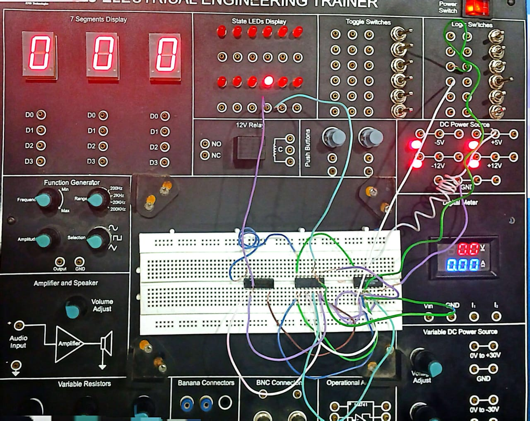

A B = Sum Carry

0 0 = 0 0

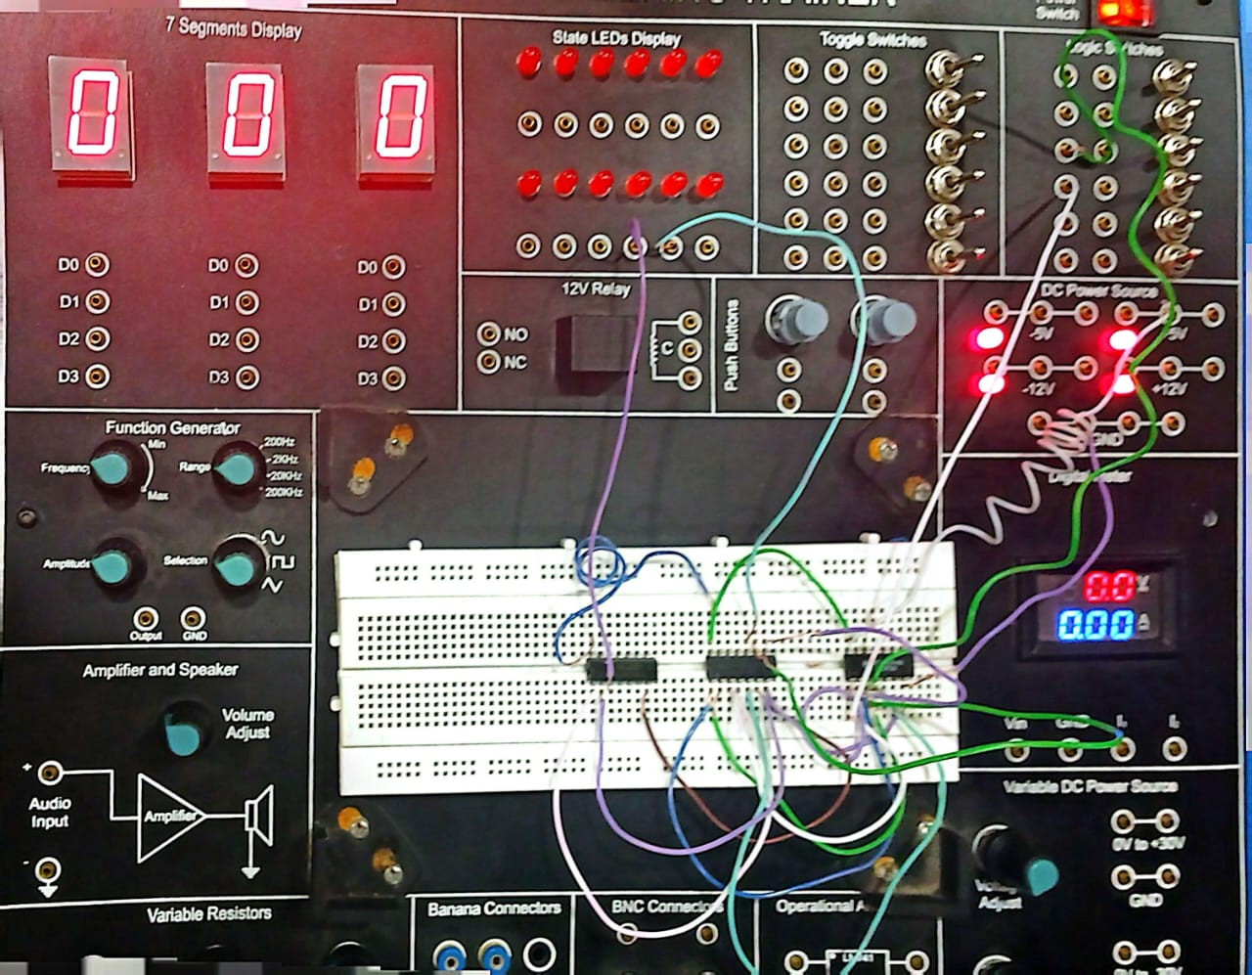

A B = Sum Carry

0 1 = 1 0

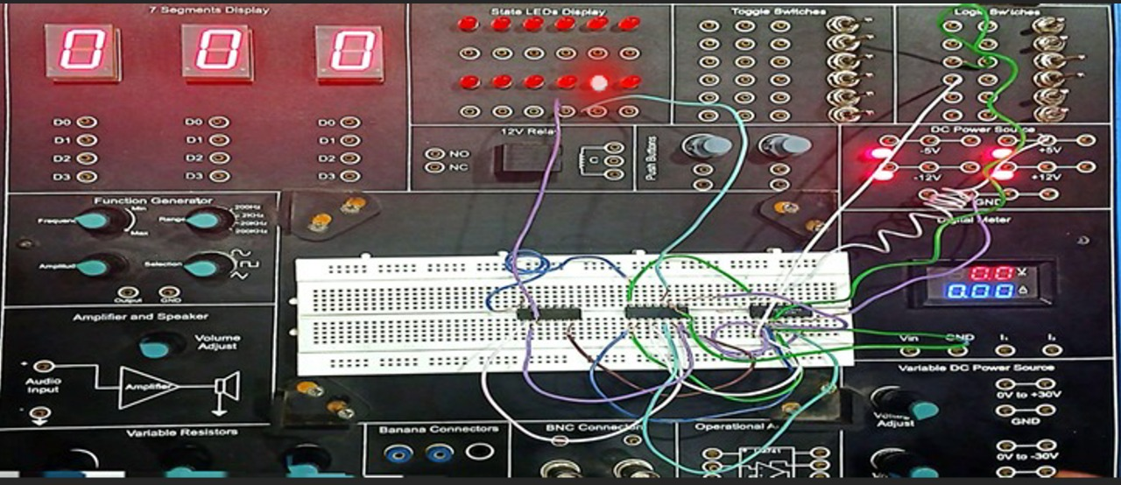

A B = Sum Carry

1 1 = 0 1



**Half Adder X-OR**

A B = Sum Carry

0 0 = 0 0

A B = Sum Carry

1 1 = 0 1

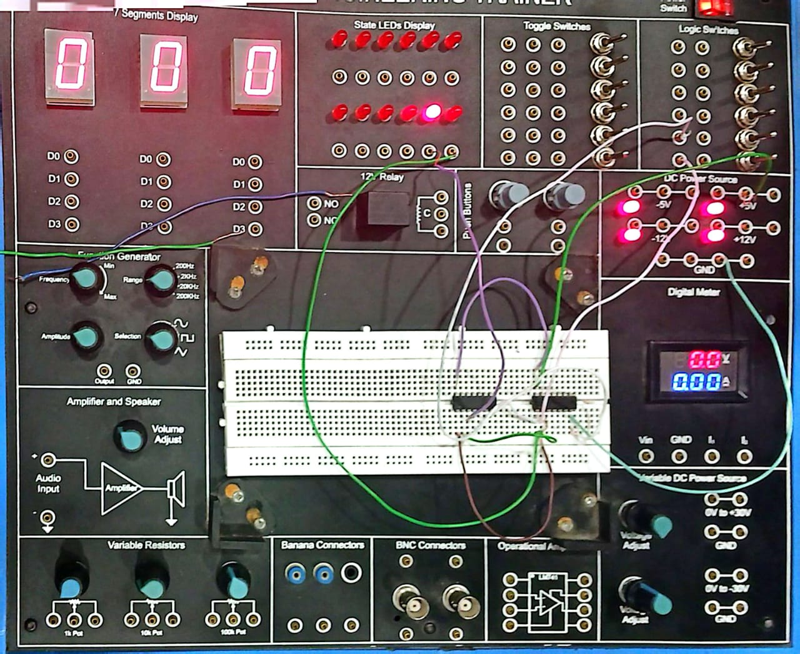

A B = Sum Carry

0 1 = 1 0

